Below are the slides pertaining to my project (Quanser Qube Servo_2) parameters and procedures. What follows is how my project can be used to apply to CAN / J1939 INDUSTRIAL TECHNOLOGY.
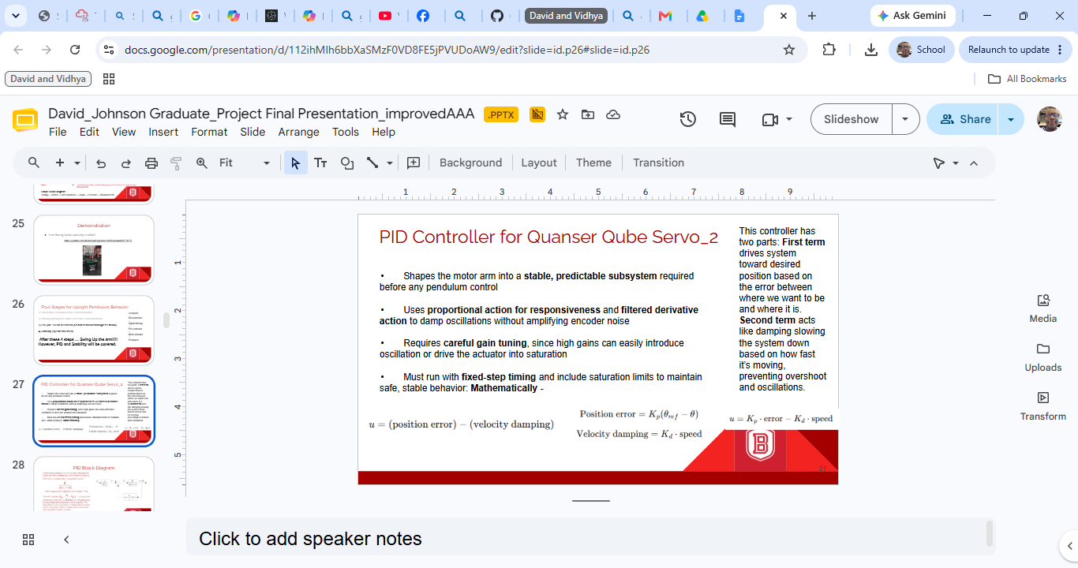
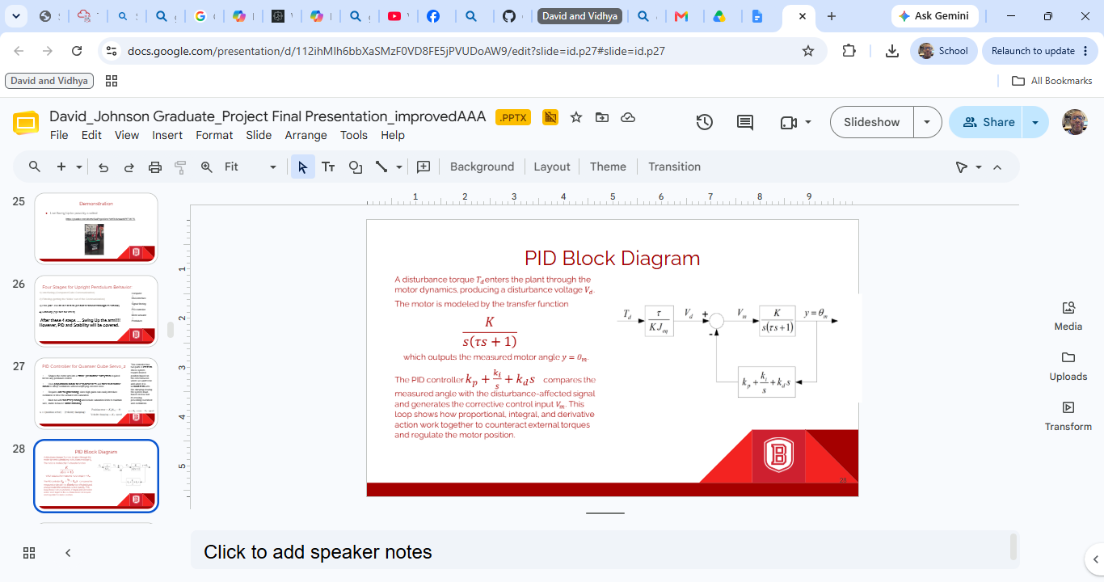
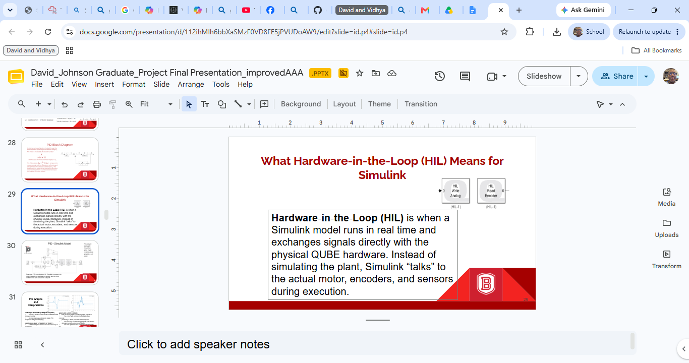
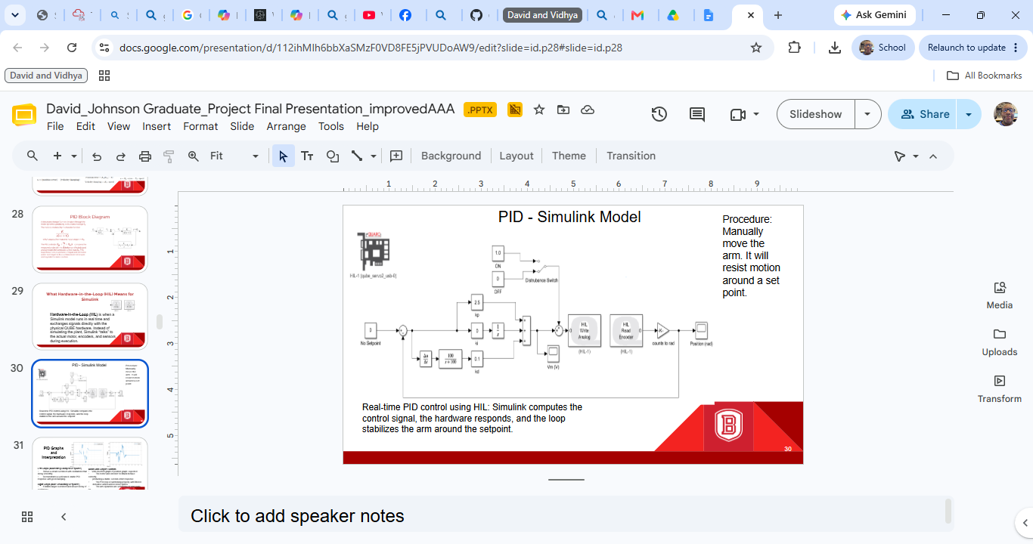
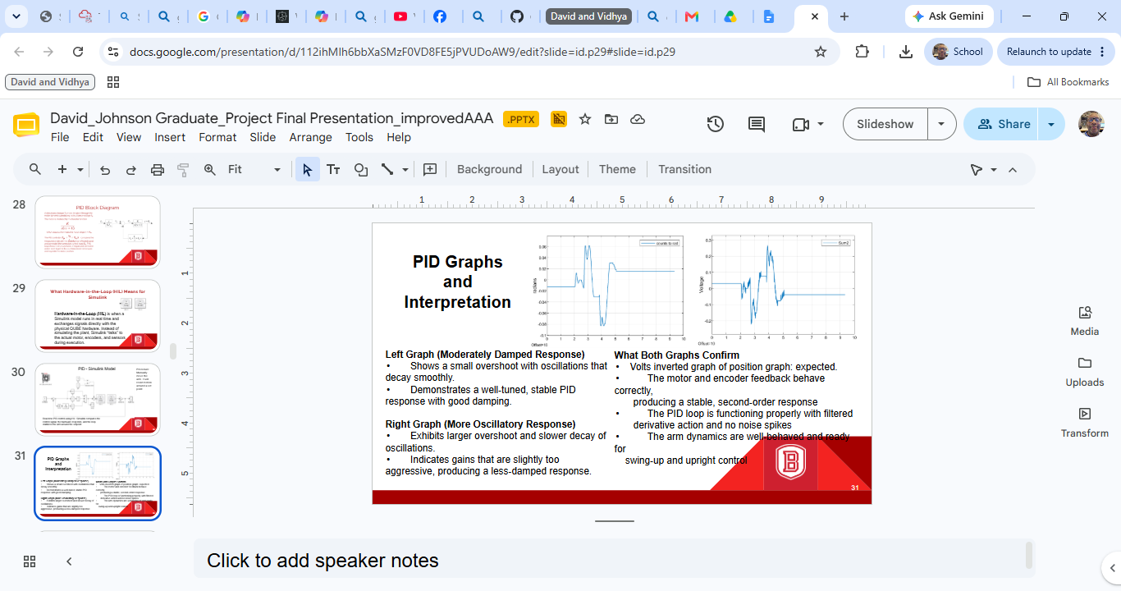
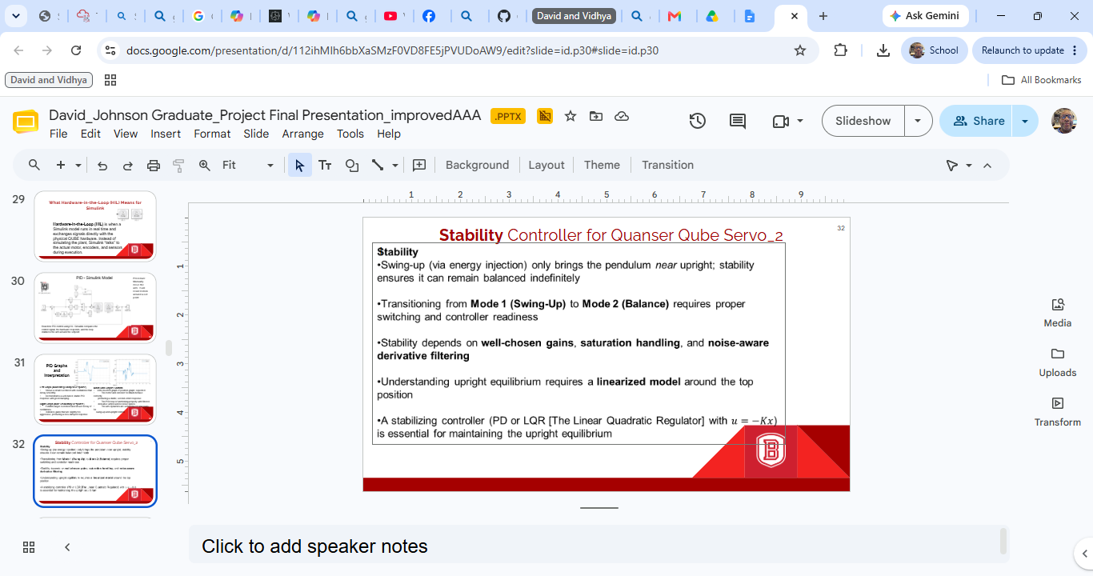
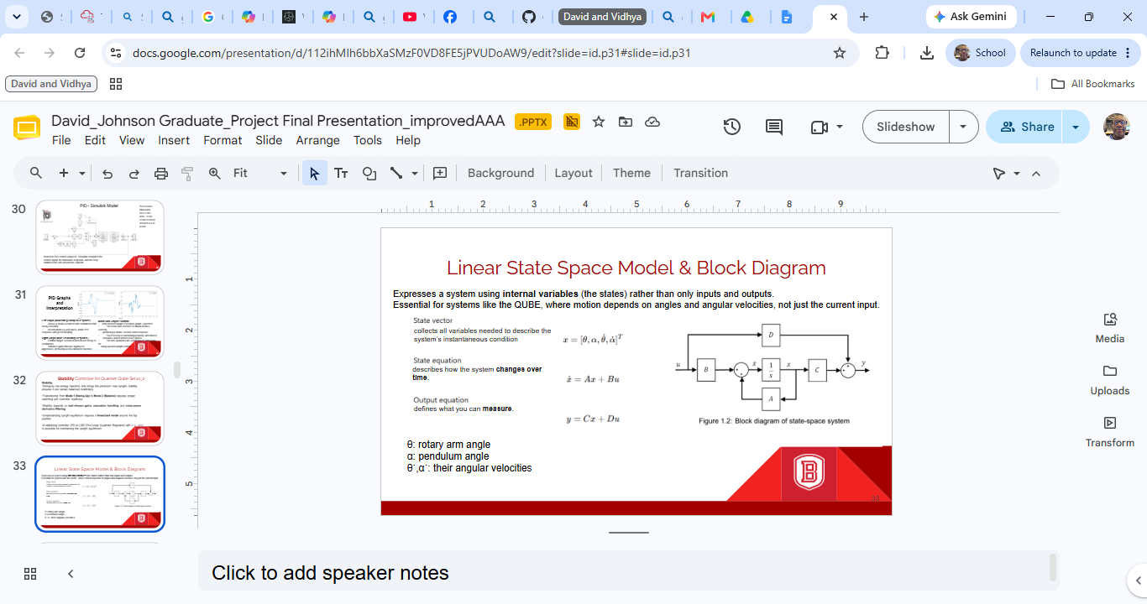
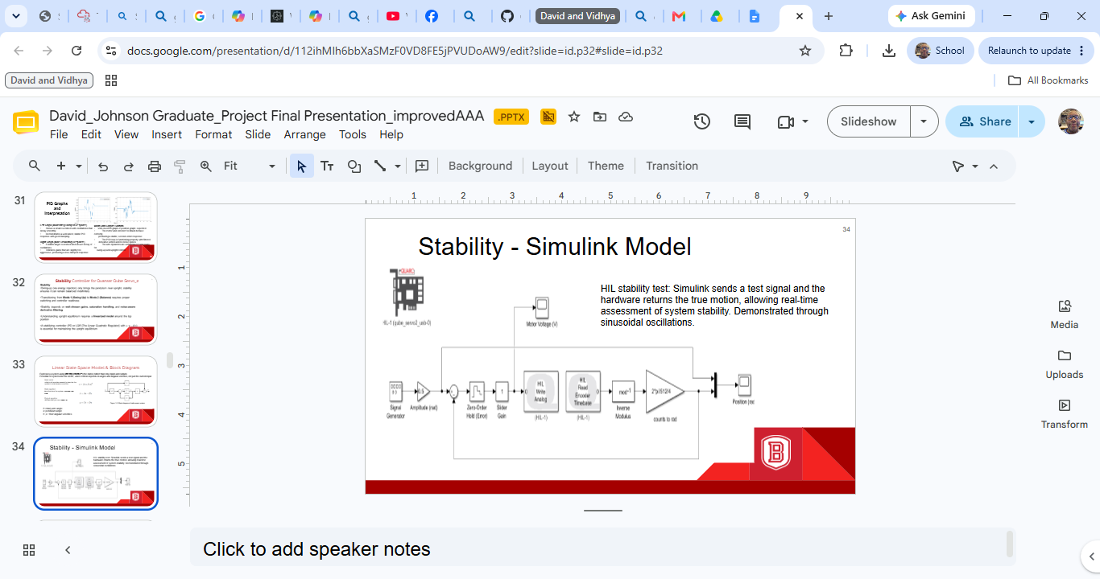
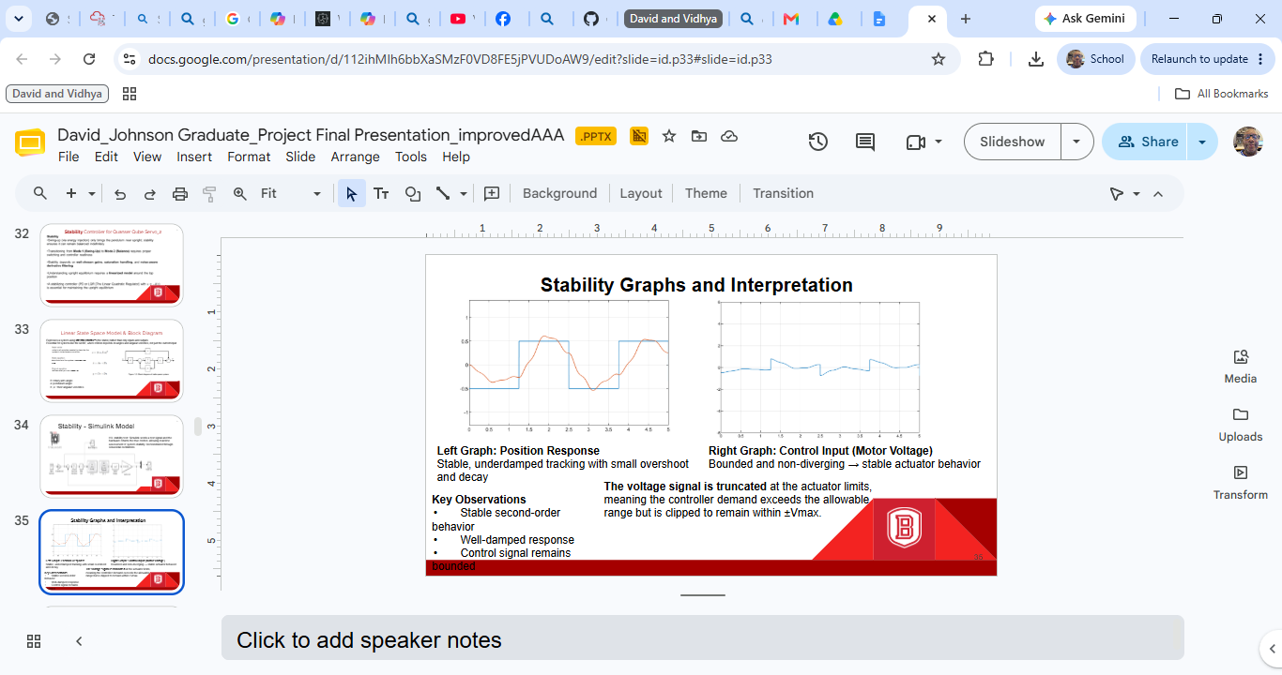
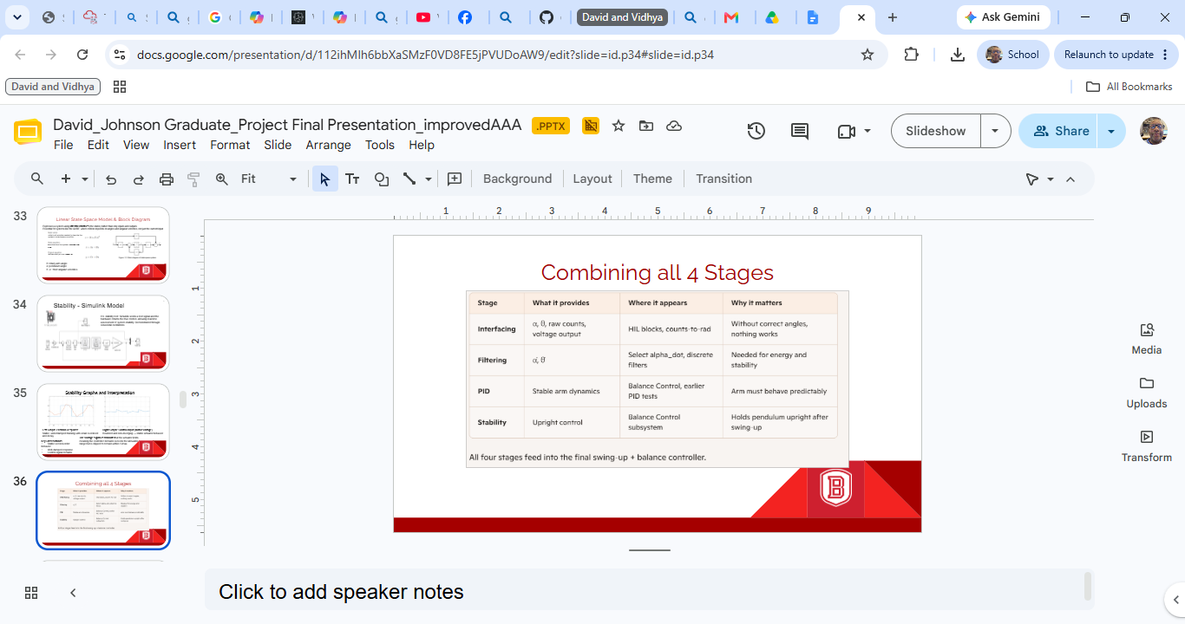
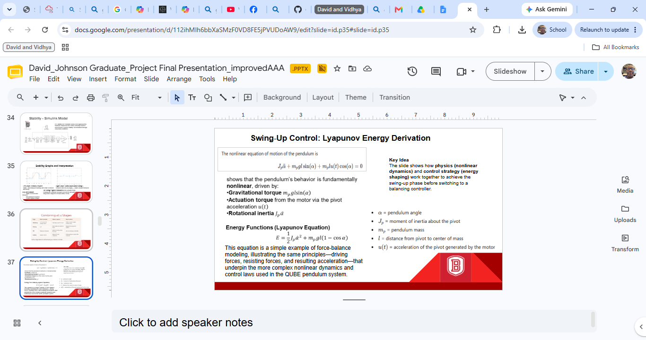

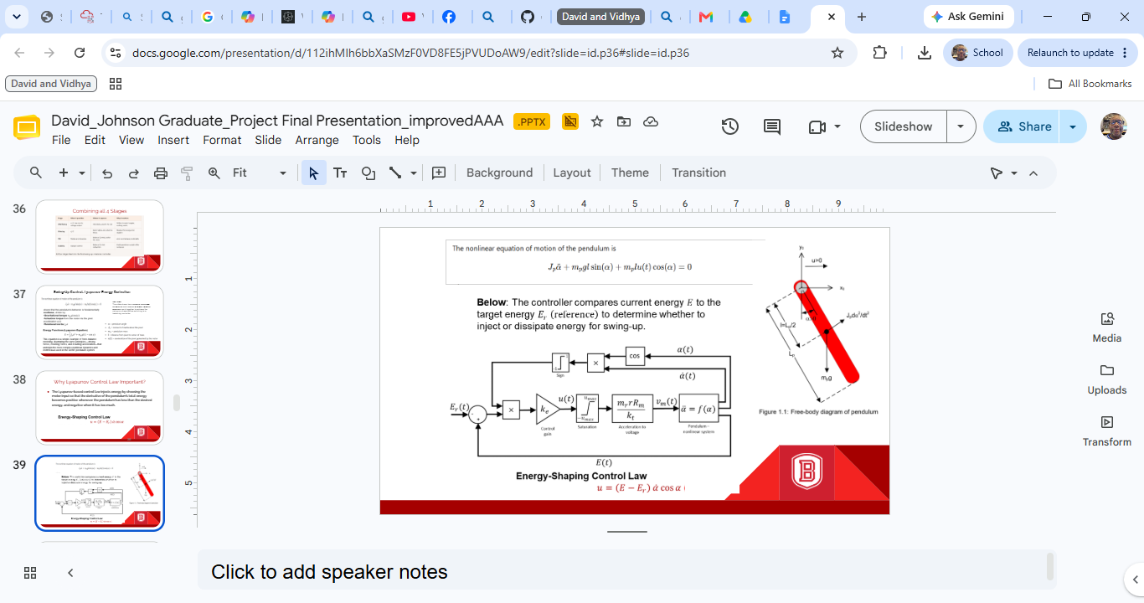
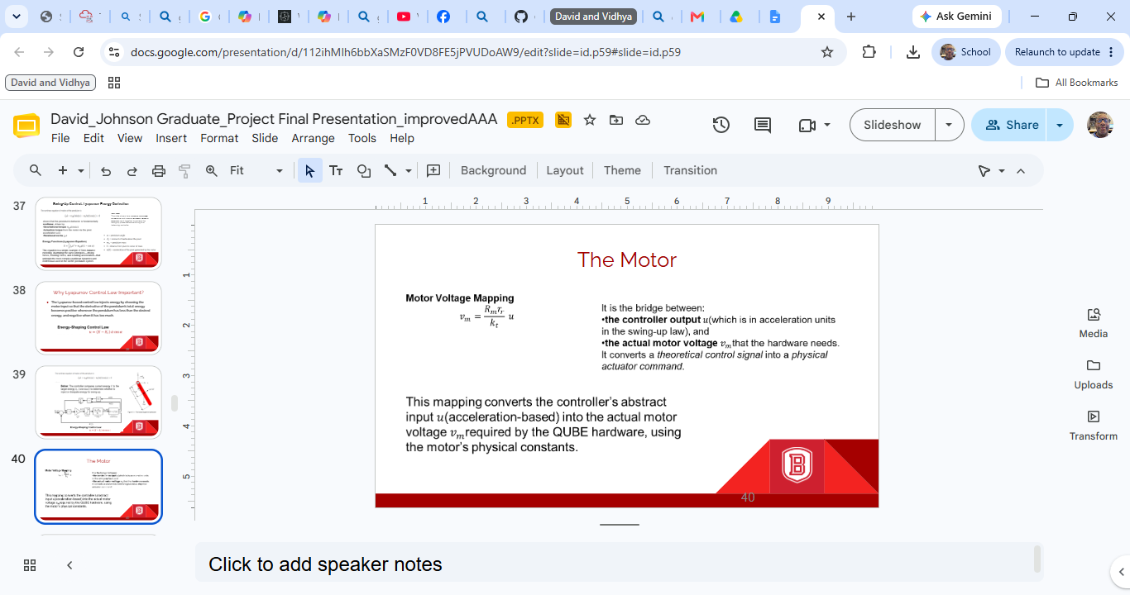
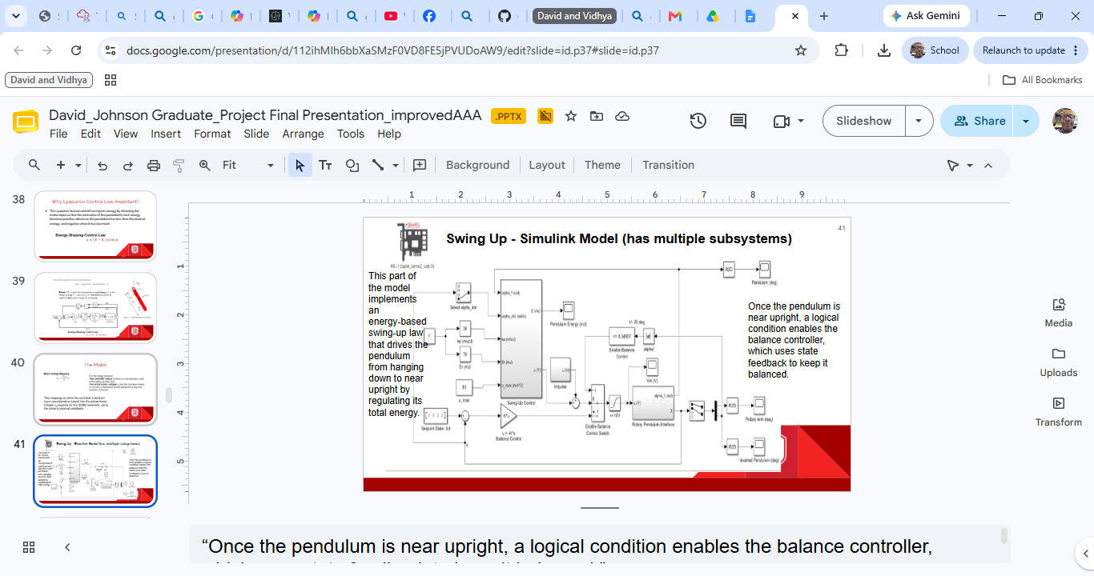
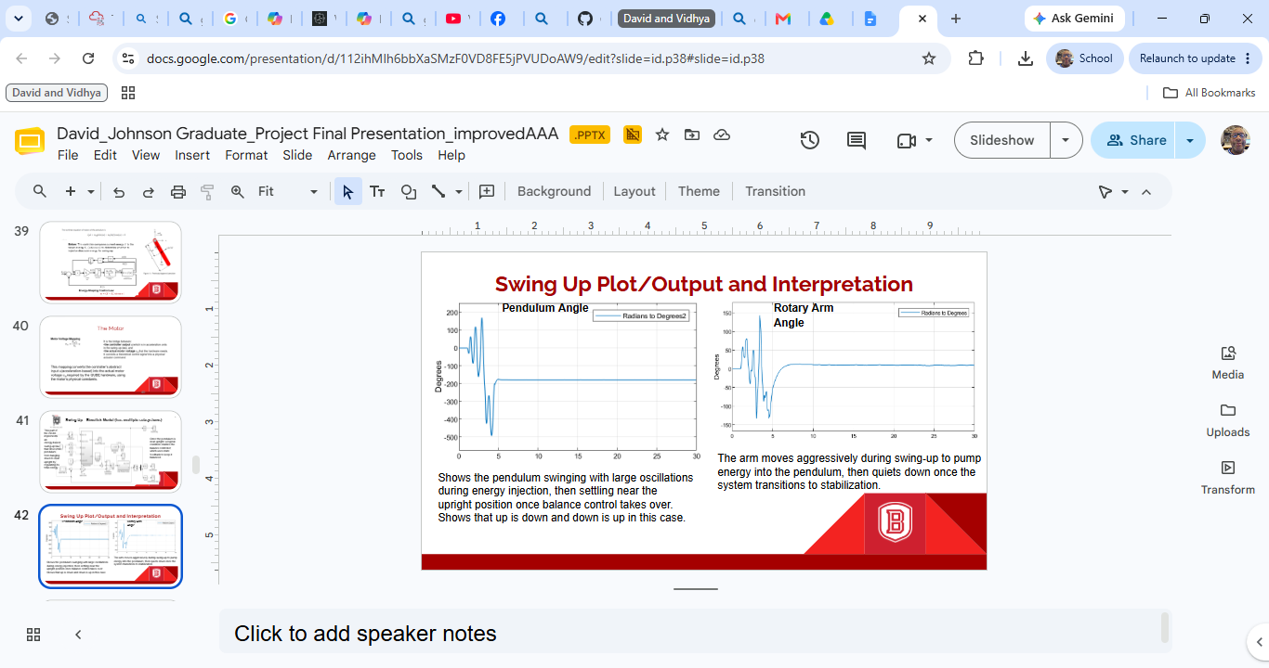
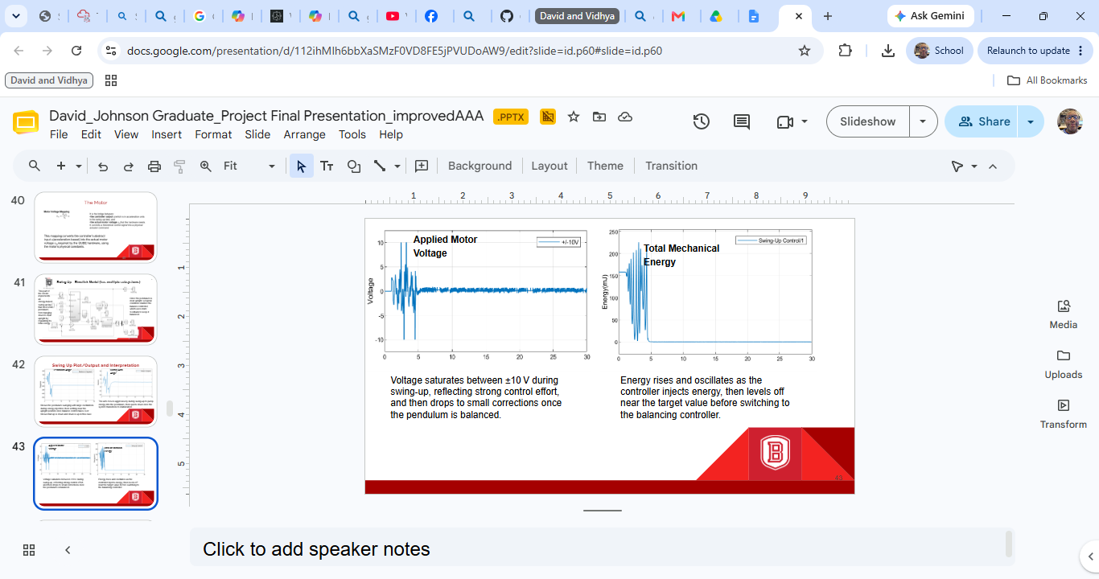
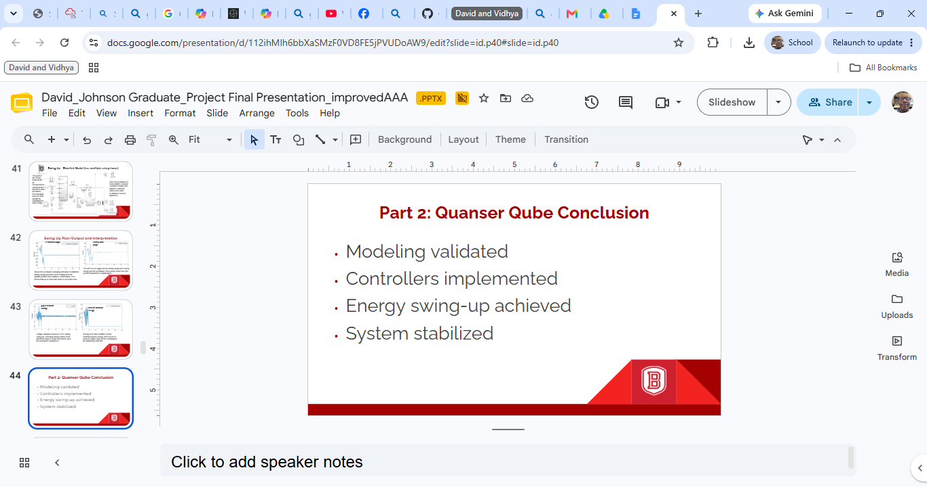
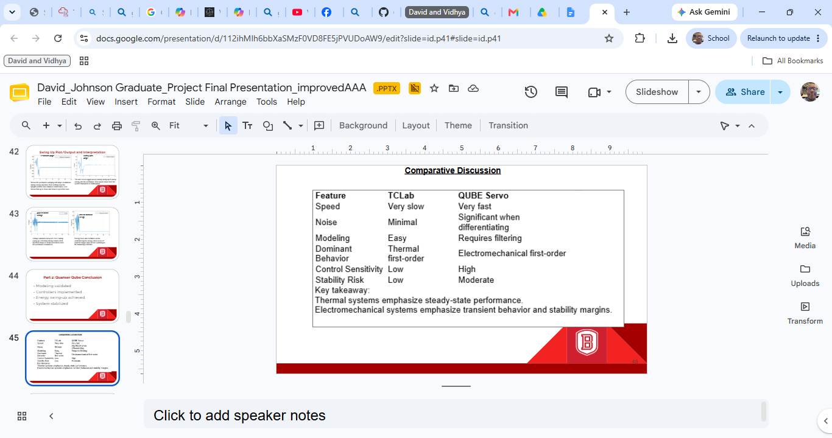
**************************************************************************************************************************************************************************
APPLICATION TO CAN / J1939 ……
The graph presented below shows how MY project parameters would transfer into CAN / J1939, followed by the interpretation phrased exactly like a Cat validation report.
📈 Interpretting a Fabricated Caterpillar-Style PGN/SPN Field-Test Graph
(Color-coded, professional, validation-ready)
🟦 Graph Description (as Caterpillar would write it)
PGN: 0xFEEE (Example Implement Position PGN)
SPN: 1234 – Implement Position (deg)
Test: Implement Position Response – Swing-Up & Stabilization
Machine: Simulated ECU (HIL)
Sample Rate: 10 ms (J1939-equivalent broadcast rate)

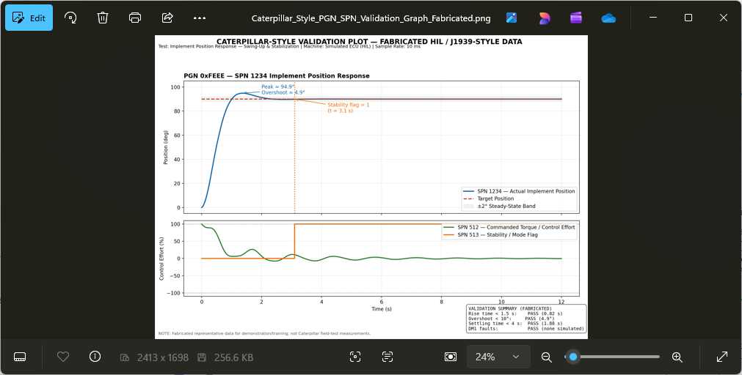
Color Coding (matches Caterpillar validation conventions)
- Blue Line: SPN 1234 – Actual Implement Position
- Green Line: SPN 512 – Commanded Torque / Control Effort
- Red Dashed Line: Target Position (Setpoint)
- Orange Line: SPN 513 – Stability / Mode Flag (0 = unstable, 1 = stable)
📝 Caterpillar-Style Interpretation (PGN/SPN Validation Language)
The position SPN (1234) exhibits a controlled rise from 0° to the commanded 90° target over the first 1.2 seconds. The overshoot is measured at 5°, followed by a damped convergence into the ±2° steady-state band by t = 3.0 s.
The torque-command SPN (512) shows a phase-aligned energy injection profile consistent with swing-up control logic. Control effort saturates briefly at 100% during the initial maneuver, then modulates to maintain stability.
The stability flag SPN (513) transitions high at t = 3.1 s, indicating the subsystem has entered a valid operating state with no active DM1 faults.
Acceptance Criteria:
- Rise time < 1.5 s → PASS
- Overshoot < 10° → PASS
- Settling time < 4.0 s → PASS
- No DM1 faults during maneuver → PASS

Result: Implement Position Control meets all J1939-based validation requirements for this maneuver.
This fabricated graph demonstrates that you already think in terms of:
- PGNs (message groups)
- SPNs (individual parameters)
- Broadcast timing (10 ms sample rate)
- Field-test acceptance criteria
- Parameter stability and convergence
- Diagnostic flags (DM1-style)
- Control effort vs. response behavior

This is exactly how Caterpillar engineers evaluate:
- Engine speed response
- Hydraulic cylinder position
- Pump displacement control
- Fan speed control
- Transmission clutch pressure
- Implement linkage motion

My HIL project maps directly onto these workflows.

